**DAILY ONLINE ACTIVITIES SUMMARY**

|  |  |  |  |  |  |  |  |  |
| --- | --- | --- | --- | --- | --- | --- | --- | --- |
| **Date:** | **23-06-2020** | | | | | **Name:** | **Anix Jugal D’Cunha** | |
| **Sem & Sec** | **8 sem , A sec** | | | | | **USN:** | **4AL16CS013** | |
| **Online Test Summary** | | | | | | | | |
| **Subject** | | **Test was not conducted today** | | | | | | |
| **Max. Marks** | | **--** | | **Score** | | | **--** | |
| **Certification Course Summary** | | | | | | | | |
| **Course** | **Learn Basic CSS3** | | | | | | | |
| **Certificate Provider** | | | **Udemy** | | **Duration** | | | **1.5 hours** |
| **Coding Challenges** | | | | | | | | |
| **Problem Statement:** Java Program to Sort a Map By Values | | | | | | | | |
| **Status: Competed** | | | | | | | | |
| **Uploaded the report in Github** | | | | | **yes** | | | |
| **If yes Repository name** | | | | | **alvas-education-foundation/dcunhaanixjugal** | | | |
| **Uploaded the report in slack** | | | | | **yes** | | | |

Online Test Details: (Attach the snapshot and briefly write the report for the same)

Test was no Conducted Today

Certification Course Details: (Attach the snapshot and briefly write the report for the same)

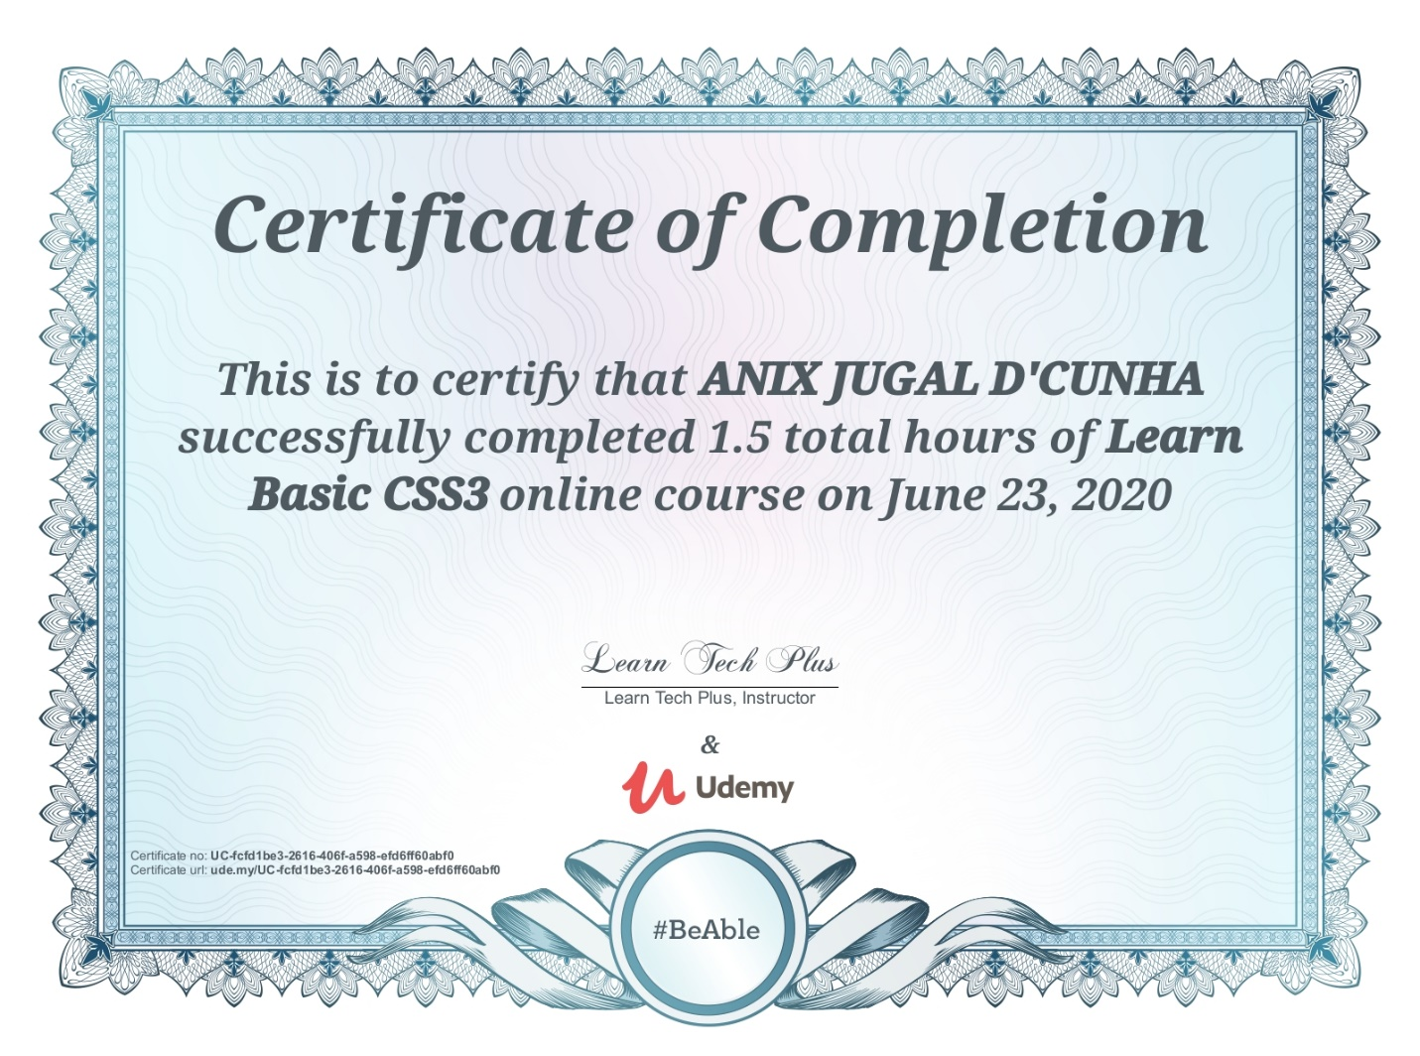

Coding Challenges Details: (Attach the snapshot and briefly write the report for the same)

Program->  Java Program to Sort a Map By Values

|  |
| --- |
|  |

import java.util.*;

public class SortMap {

public static void main(String[] args) {

LinkedHashMap<String, String> capitals = new LinkedHashMap<>();

capitals.put("Nepal", "Kathmandu");

capitals.put("India", "New Delhi");

capitals.put("United States", "Washington");

capitals.put("England", "London");

capitals.put("Australia", "Canberra");

Map<String, String> result = sortMap(capitals);

for (Map.Entry<String, String> entry : result.entrySet())

{

System.out.print("Key: " + entry.getKey());

System.out.println(" Value: " + entry.getValue());

}

}

public static LinkedHashMap<String, String> sortMap(LinkedHashMap<String, String> map) {

List<Map.Entry<String, String>> capitalList = new LinkedList<>(map.entrySet());

Collections.sort(capitalList, (o1, o2) -> o1.getValue().compareTo(o2.getValue()));

LinkedHashMap<String, String> result = new LinkedHashMap<>();

for (Map.Entry<String, String> entry : capitalList)

{

result.put(entry.getKey(), entry.getValue());

}

return result;

}

}